Urban Pluse
Dashboard Build Report
Passenger Demand Heat Map · Tableau Flow Map · Route Performance Analysis Dashboard

1. Executive Summary
This report documents three completed BI deliverables built on the India transit dataset: (1) a Power BI passenger-demand heat map covering all of India with a City/Transport Mode filter panel, (2) a Tableau flow map showing route-level passenger flow for Chennai by transport mode, and (3) a route performance analysis dashboard combining four KPI cards with a bar chart and a column chart. Screenshots of each live dashboard are embedded below.

2. Task 1 — Passenger Demand Heat Map
Built in Power BI, this dashboard plots passenger demand across Indian cities using Latitude/Longitude as the geographic base, with bubble color reflecting Traffic_Status (High, Low, Moderate, Severe) and bubble size reflecting passenger volume. A City slicer and a Transport_Mode slicer let the viewer filter the map, and two KPI cards summarize Total Passengers and Total Vehicles for the current filter selection.

2.1 National View
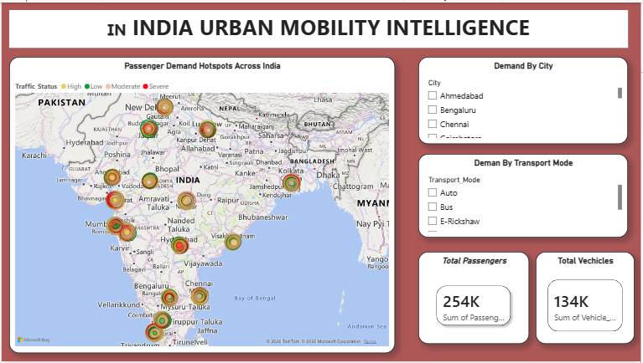
Figure 1. Passenger Demand Hotspots Across India — unfiltered view. Total Passengers: 254K · Total Vehicles: 134K.

2.2 Filtered View — Chennai
Selecting "Chennai" in the City slicer narrows the map to that metro area and recalculates both KPI cards in place, demonstrating the cross-filtering behaviour between the slicers, map, and cards.
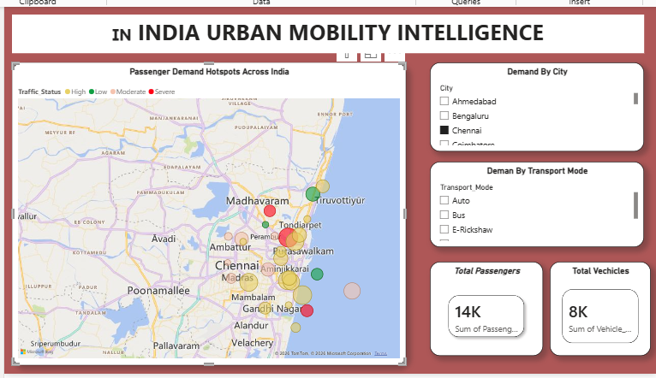
Figure 2. Passenger Demand Hotspots — filtered to City = Chennai. Total Passengers: 14K · Total Vehicles: 8K.
View | Total Passengers | Total Vehicles
All India (unfiltered) | 254K | 134K
Chennai (filtered) | 14K | 8K

3. Task 2 — Tableau Flow Map
Built in Tableau, the Flow Map worksheet visualizes passenger flow between transit points as connected lines. Longitude and Latitude are placed on Columns and Rows respectively (as averages), the mark type is set to Line, and Transport Mode drives line color while SUM(Passenger Count) drives line/mark size. Transit ID supplies path detail and Path Order sequences each route's points. City and Transport Mode filters on the right panel let the view be scoped down, currently set to City = Chennai with all transport modes included.

3.1 Worksheet Build
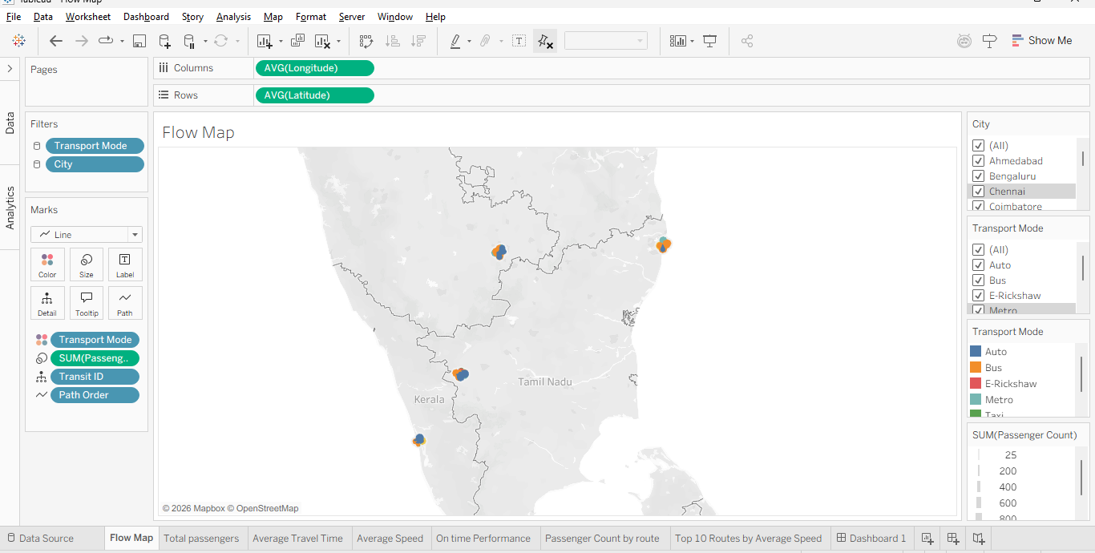
Figure 3. Tableau worksheet configuration for "Flow Map" — Columns/Rows, Marks (Line), and the Color/Size/Detail/Path encoding shelf, with City and Transport Mode filters visible on the right.

3.2 Resulting Flow Map — Chennai
Zoomed into Chennai, the flow lines show passenger routes colored by mode (Auto, Bus, E-Rickshaw, Metro, Taxi), with thicker lines indicating higher SUM(Passenger Count) along that route. Bus (orange) routes dominate in both count and reach, radiating across the city, while Metro (teal) and E-Rickshaw (red) routes are shorter and more localized.
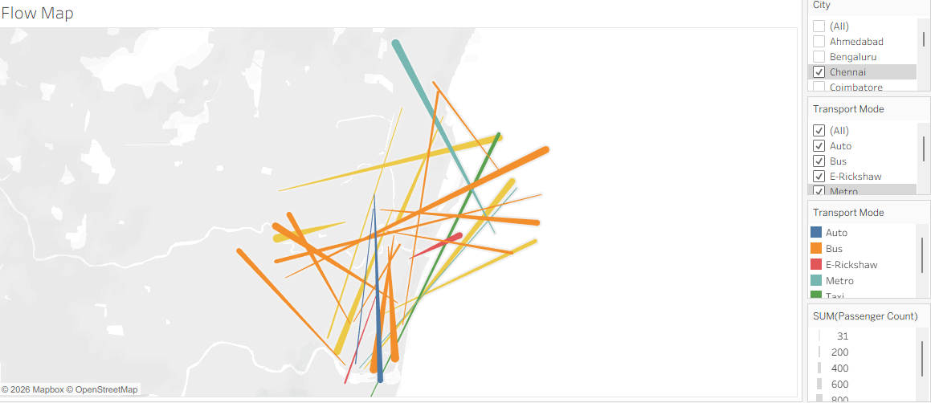
Figure 4. Flow Map output — Chennai transit routes by Transport Mode, sized by SUM(Passenger Count).

4. Route Performance Analysis Dashboard
This dashboard combines four KPI cards with a bar chart and a column chart to summarize route-level performance for the current selection.

4.1 KPI Cards
KPI | Value
Total Passengers | 2,56,859
Average Travel Time | 32.13 (minutes)
Average Speed | 30.94 (km/h)
On Time Performance | 18.40%

Filtered Dashbbaord
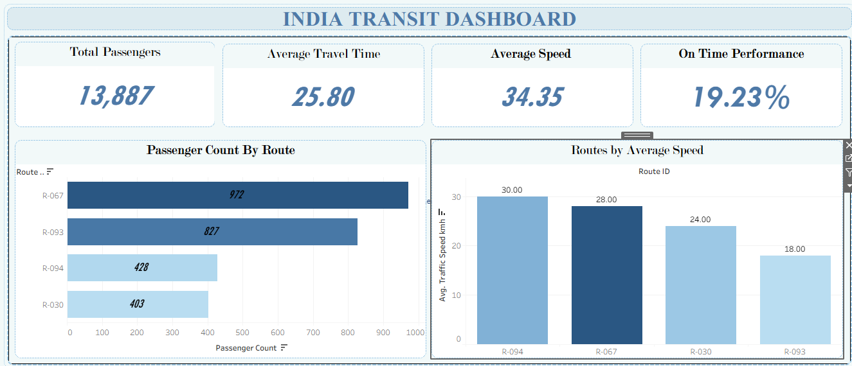

4.2 Passenger Count By Route (Bar Chart)
Route ID | Passenger Count
R-067 | 972
R-093 | 827
R-094 | 428
R-030 | 403

4.3 Routes by Average Speed (Column Chart)
Route ID | Avg. Traffic Speed (km/h)
R-094 | 30.00
R-067 | 28.00
R-030 | 24.00
R-093 | 18.00

4.4 Complete Dashboard Screenshot
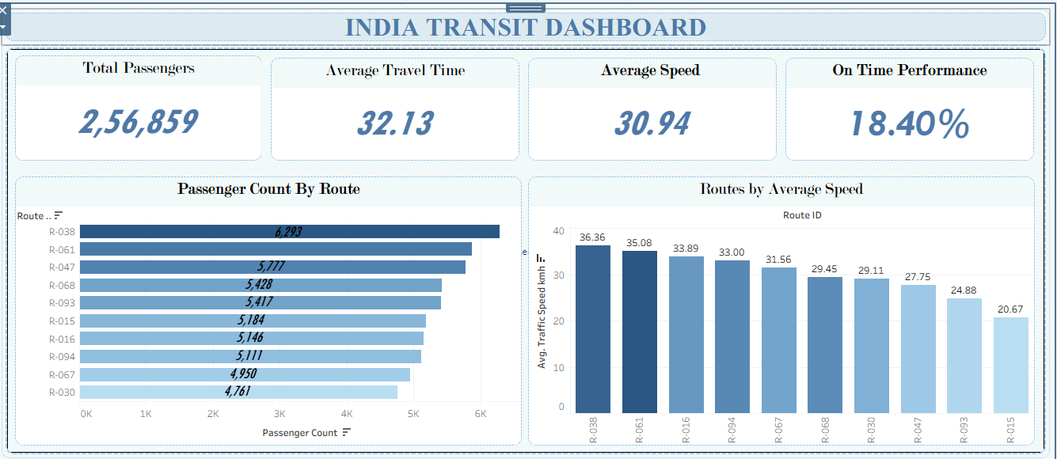
Figure 5. India Transit Dashboard — four KPI cards, Passenger Count By Route (bar chart), and Routes by Average Speed (column chart).

